Q16. Read the following discussion of program design and then answer Sub-Questions 1 through 3.

Before performing monthly payment processing, Company A printed out the forecasted payment amounts for each payee, and then checked the amounts manually. The company then decided to move this work to a computer system by creating a program that extracted payment data according to certain conditions on the server side, and then presented that information for authorization on a client terminal.

[Description of Payment Checking and Authorization System]
(1) Upon starting up the system, the account name and password entry screen appears on the client terminal. Only an authorized administrator with the proper registered account name and password can use this system. The month and year for the payment in question are also entered on this screen.
(2) The server program reads the payment tabulation file in which the information for each payee is stored in an individual record. If it finds that even one of the following conditions applies to a record for the specified month and year, that record becomes subject to authorization processing. There are approximately 20 records that are targeted each month. The values that are checked for each of the conditions are given to the program as a table of conditions.
① Condition 1: The payment amount for the month exceeds the upper limit that was set for that payee.
② Condition 2: When the month’s payment is included, the cumulative payments made to that payee for the fiscal year exceeds 20 million ‘yen’ (or the cumulative amount had already exceeded this limit).
③ Condition 3: The payment amount for the month exceeds 3% of the total payments being made to payees that month.
④ Condition 4: The payment amount for the month is in the top 5% of all amounts for the payment tabulation records that are being paid that month.
(3) The server program edits the data to be sent (based on the contents of the payment tabulation records that are subject to authorization processing, the conditions table, and the various files), and then sends the data to the client program. The following editing is performed on authorization items 1 through 4.
Note that each of the authorization items 1 through 4 corresponds to the condition with the same number.
① If any of the conditions set forth in (2) above apply to a record, the values (initially a space) of the authorization items in the payment tabulation record are copied to the corresponding authorization items in the data to be sent.
② If some of the conditions set forth in (2) above do not apply to a record, the character string “Does Not Apply” is copied to the corresponding authorization items in the data to be sent.
(4) The client program generates and displays a payment authorization screen based on the data that was sent to it by the server (See Fig. 1). The authorization input display is created as follows, depending on the value of each of the authorization items 1 through 4:
① When the value of an authorization item is a space, the program displays a corresponding description and an “Authorize” button.
② When the value of an authorization item is not a space, the program displays a corresponding description followed by the edited contents.
(5) When the “Authorize” button on the payments authorization screen is clicked, the server program records the date and time of the authorization and the name of the authorizing party in the corresponding authorized item in the corresponding payment tabulation record.
(6) When the “Next Record” button on the payment authorization screen is clicked, the server program repeats the processing, starting at (2) above. When the “Finish” button is clicked, the program ends.
(7) Fig. 1 shows an example of the payment authorization screen. Fig. 2 shows the system configuration. Fig. 3 shows the program structure.
(8) The format of each file and the contents of the conditions table are shown below.
Payment tabulation file format
Payment month and year | Payee code | Payment amount | Authorization item 1 |  |  |  |  | Authorization item 4
Payment month and year | Payee code | Payment amount | Authorization date and time | Name of authorizing party |  |  |  | Authorization date and time | Name of authorizing party

Note: The payment authorization table contains data for the most recent 12 months. Only one record exists for a given payment month and payee code. The initial value for authorization items 1 through 4 is a space.
Comparison standards file format
Payment month and year | Payee code | Payment upper limit amount | Cumulative payment for this fiscal year | Percentage ranking of payment for current month
Note: The payment upper limit amount is predetermined and set up ahead of time. The cumulative payment for this fiscal year and the percentage ranking of the payment for the current month are both calculated and set before the payment checking and authorization system is used.
Payee file format
Payee code | Name of payee

Payment total file format
Payment month and year | Total payments for month
User file format
Account name | Password | Name

Conditions Table
Condition No. | Threshold for checking | Display text (fixed portion)
1 | ⎯ | The payment amount exceeds the upper limit for this payee.
2 | 20,000,000 | The cumulative payments for the current fiscal year will (or already) exceed 20 million yen.
3 | 3 | This payment is more than 3% of the total payments for the month.
4 | 5 | This payment is in the top 5% of the payments for the month.

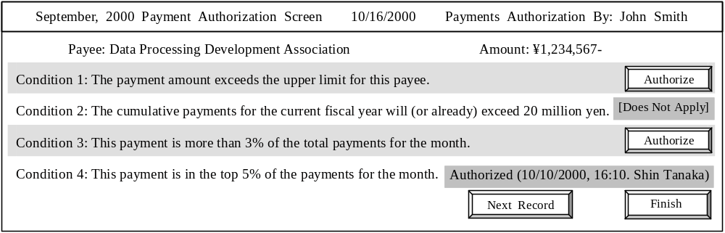
Fig. 1 Example Client Terminal Display

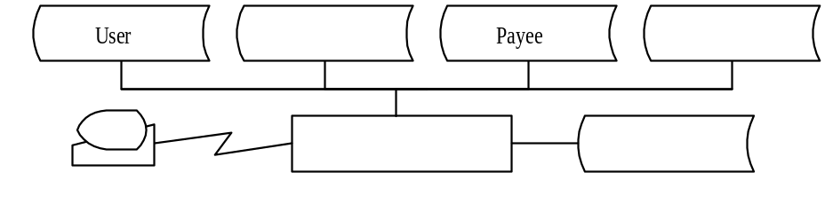
User
Payee
Total payment amount
Comparison standards
Payment authorization request
Payment tabulation
Client terminal
Fig. 2 System Configuration
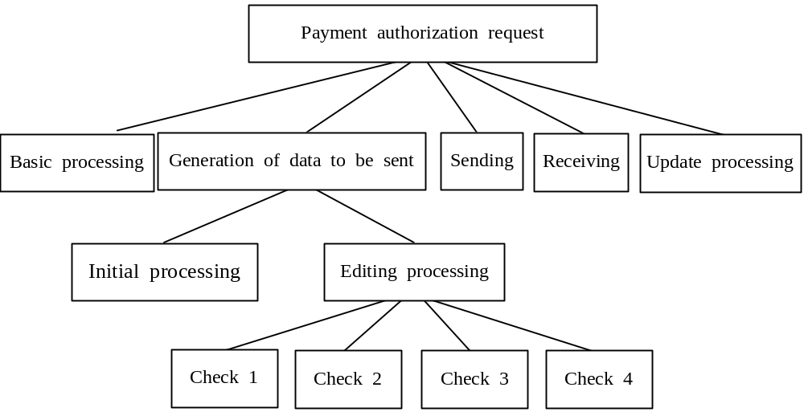
Fig. 3 Structure of the Server Program

Sub-Question 1
Select the correct answer from the choices provided to be inserted into the  in the format of the data that is sent to the client terminal, shown below.

Format of sending data
 | Payee | Payment  amount | Display text  for condition 1 | Authorization item 1 |  |  |  | Display text  for condition 4 | Authorization item 4
Answer group:
a) Condition number b) Limit value
c) Payee code d) Payment month and year
e) Name of authorizing party f) Total payments for month

Sub-Question 2
In the payment authorization request processing, items which only need to be set once are set in the basic processing, while items that have a different value for each payee are set in the initial processing. Select the correct answers to be insertted into  and  in Table 1 from the choices provided below.
Checks 1 through 4 correspond to the conditions with the same number. No file reads are performed during checks 1 through 4.

Table 1 Items That Are Used in Check Processing and the Modules That Set Those Items
Name of module that sets the item | Basic processing | Initial processing
Items used in check 2

Answer group:
a) Account name b) Threshold for checking
c) Percentage ranking of payment for this month d) Total payments for this month
e) Cumulative payments for this fiscal year f) Password

Sub-Question 3
Among the processing that is performed in the initial processing in Fig. 3, select the correct order of processing for P1 through P4 shown in Table 2.

Table 2 Descriptions of Processing That Is Performed in Initial Processing
Process name | Description of processing
P1 | Reads the record in the payment tabulation file.
P2 | Reads the record in the payee file.
P3 | Copies the corresponding values to each item in the data to be sent.
P4 | Copies a space to all items in the data to be sent.

Answer group:
a) P1 → P2 → P4 → P3 b) P1 → P3 → P4 → P2
c) P2 → P1 → P4 → P3 d) P4 → P3 → P1 → P2
e) P4 → P3 → P2 → P1
Comment: ‘yen’ should be replaced by the currency in your country.
Ans:
Sub 1: Đáp án E. Tổ chức authorized.
Sub 2: Đáp án a – B, b – E. Thông tin cần thiết ở đây là ngưỡng tiền và lượng tiền tích lũy. Lượng tiền tích lũy cần thiết cho việc sinh ra data để gửi đi nên nó ở phần Initalize Processing còn ngưỡng tiền là các tham số đầu vào nên nó ở phần Basic Processing.
Sub 3: Đáp án A. Dễ thấy ta phải đọc record của phần bảng trước, vì nó xác định số lượng thông tin cần có P1. Sau đó là P2 để lấy đầy đủ thông tin. Sau đó là P4 để định dạng thông tin, cuối cùng là P3 để đưa thông tin vào.

